H.T No
Regulations:
A18


Sreenidhi Institute of Science and Technology
(An Autonomous Institution)
Code No: 7HC07 Date: 29-Dec-2018 (FN)

B.Tech I-Year I-Semester End External Examination, Dec-2018/Jan-2019 (Regular)
MATHEMATICS - I (CSE, IT and ECM)

Time: 3 Hours Max.Marks:75

Note: a) No additional answer sheets will be provided.
b) All sub-parts of a question must be answered at one place only, otherwise it will not be valued.
c) Missing data can be assumed suitably.

Part - A Max.Marks:25

Answer all QUESTIONS.

1. | Evaluate 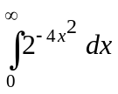 using Gamma function. | [3M]
2. | Write the geometrical interpretation of Lagrange’s mean value theorem. | [3M]
3. | Find the rank of the matrix 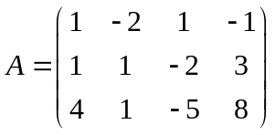 . | [3M]
4. | Define basis of a vector space. Give an example. | [3M]
5. | The Eigen values of A⁻¹, where 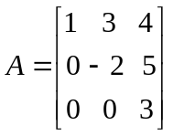 | [3M]
6. | Give an example of an inner product space. | [2M]
7. | Define Beta and Gamma functions. | [2M]
8. | Write the definition of vector space. | [2M]
9. | Find the sum and product of the Eigen values of the matrix 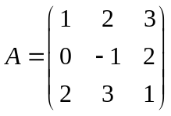 . | [2M]
10. | Discuss the applicability of Rolle’s theorem for 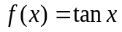 in 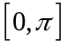. | [2M]
Part – B Max.Marks:50
ANSWER ANY FIVE QUESTIONS. EACH QUESTION CARRIES 10 MARKS.

11. | a) | Find the evolute of the curve 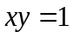. | [5M]
 | b) | Find the volume of the solid generated by revolving the region bounded by the curves 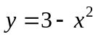 and 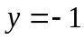 about the line . | [5M]
12. | a) | State Cauchy’s mean value theorem . Find the value of C of the theorem for the functions 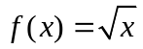 and 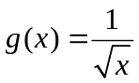 in [ 2, 8]. | [5M]
 | b) | Expand 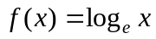 in powers of 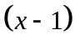 | [5M]
13. | a) | Using the Gauss-Jordan method, find the inverse of the matrix 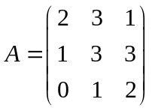 . | [5M]
 | b) | Solve the system of equations  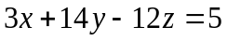 using Gauss elimination method. | [5M]
14. | a) | Determine whether the set of vectors { ( 2,2,0), ( 3,0,2), ( 2, -2, 2) } forms  a basis in 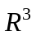. | [5M]
 | b) | Let 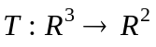 be a linear transformation, where 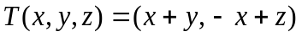.  Find the rank and nullity of the transformation T . | [5M]
15. |  | Find the Eigen values and the corresponding Eigen vectors of the matrix 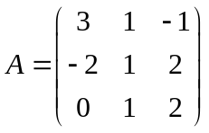. | [10M]
16. |  | Using the Gram-Schmidt orthogonalization process, obtain an orthonormal basis of for the set of linearly independent vectors { ( 2,2,0), (3,0,2), ( 2,-2,2)} | [10M]
17. | a) | Evaluate 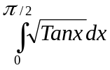. | [5M]
 | b) | Find the values of and  for which the system of equations 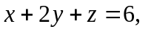  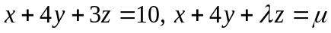 has i) a unique solution ii) an infinite number of solutions and iii) no solution. | [5M]
18. | a) | Let 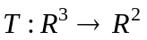 be a linear transformation defined by 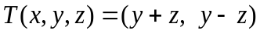.  Determine the matrix of the linear transformation T with respect to the basis  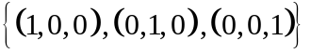 in and 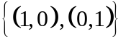 in 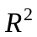. | [5M]
 | b) | If 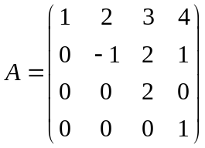,  Find the Eigen values of the matrix 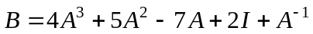. | [5M]

-- 00 -- 00 –

